Project professional:
Below is the current detection method which has been used in Project professional app created using recast is same as the detection method used for office 365 applications for current channel , because of which if on a particular device with office 365 is installed the project app will not be installed and vies verse . So we request you to make changes in the detection method so that Project app can successfully install on any device on which office app is installed.
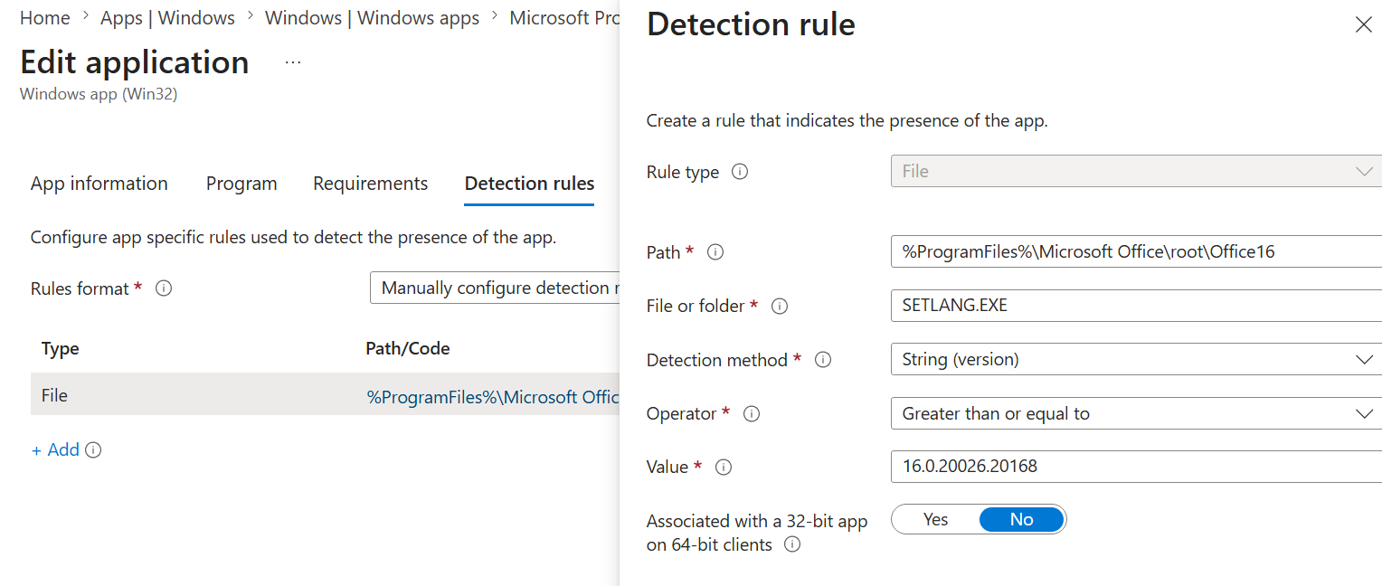
Office 365 detection method:
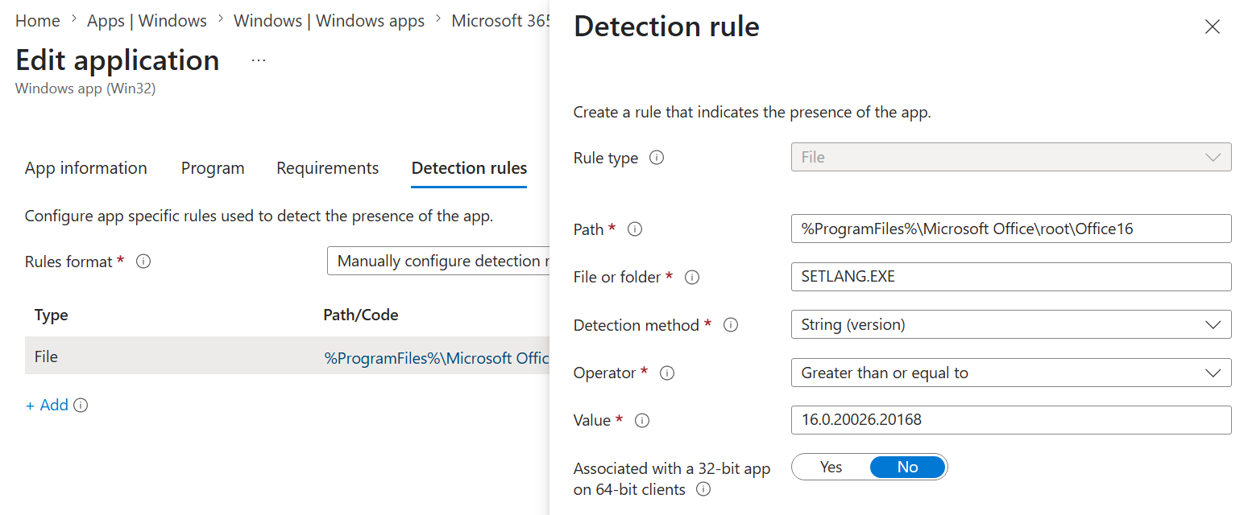
Below is an example of detection method which will work for the Microsoft project professional application.
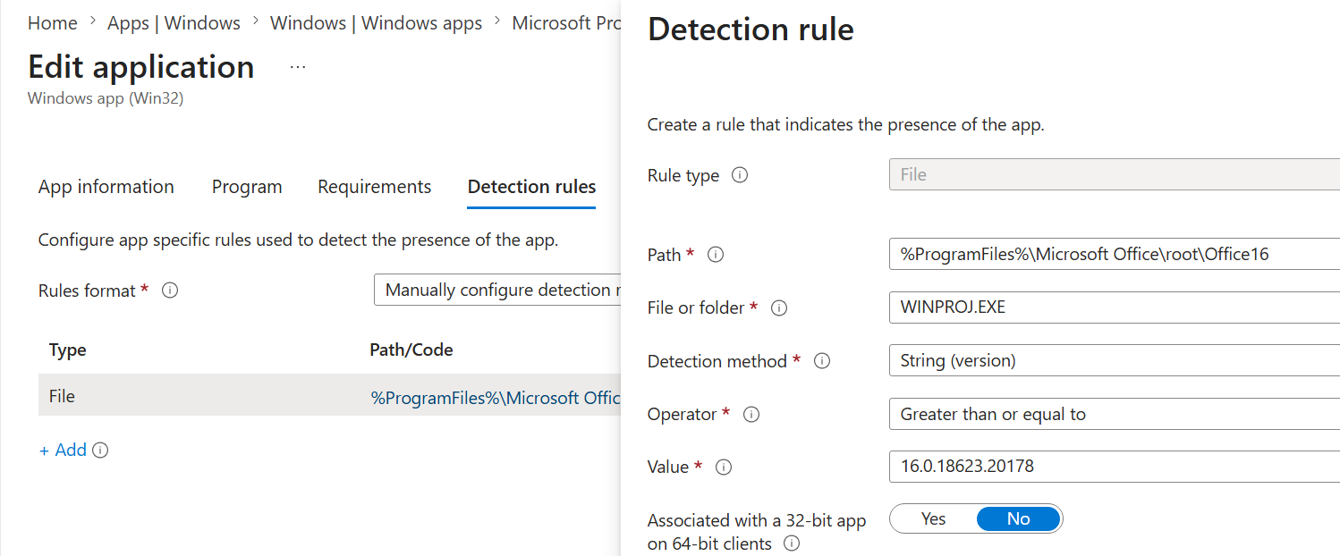

So we request you to make changes in project application.

